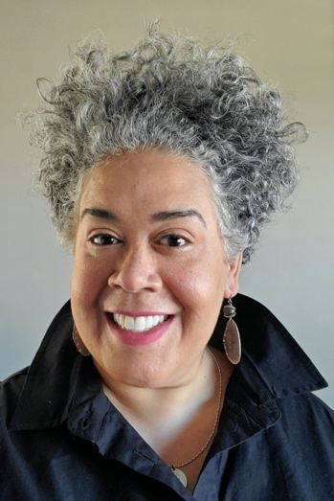
Alysia Burton Steele, Pulitzer-Prize winning journalist is author of the book “Delta Jewels: In Search of My Grandmother’s Wisdom.” The book is a collection of formal portraits and oral histories from church mothers, including civil rights activist Mrs. Myrlie Evers - widow of NAACP leader Medgar Evers. The women share poignant highlights about life during the Jim Crow era in Mississippi, including stories about the Civil Rights Movement, voting, sending the first child to college, picking cotton on plantations, fighting to receive an education and demanding to have Mrs. next to their names in the telephone book like their White counterparts.
The book, released nationwide in April 2015, has been endorsed by activist Gloria Steinem, Miami Herald Pulitzer-Prize winning columnist Leonard Pitts, Jr., best-selling author Roy Blount, Jr. and national poet Rachel Eliza Griffiths, to name a few. NYT best-selling author Bishop T.D. Jakes featured her story in his 2015 DocuSeries Destiny Visions because of her passion for oral history. She is only one of three artists in the United States featured in the series.
Delta Jewels has been featured in various national publications including: The New York Times, National Public Radio, Southern Living, NBC. com, USA Today, Chicago Sun-Times, The Atlanta Journal-Constitution, Garden & Gun, Theroot.com (owned by Washington Post), and the Jackson Clarion-Ledger. Delta Jewels has been accepted into the Library of Congress and Steele will be presenting her work to the Smithsonian’s Anacostia Community Museum in Washington, D.C. in March 2016. Her book was a finalist in the esteemed Jessie Redmon Fauset Award for nonfiction and she was awarded the Ofield Dukes Educator of the Year Award from the National Black Public Relations Society in Washington, D.C. Also, the Mississippi Humanities Council, which is funded by Congress through the National Endowment for the Humanities, named her the “2016 Preserver of Mississippi Culture” award.

Steele worked at several newspapers, including The Columbus Dispatch and The Atlanta Journal-Constitution where she worked as a picture editor and deputy director of photo. In 2006, she was part of the photo team for The Dallas Morning News that won the Pulitzer Prize in Breaking News for their Hurricane Katrina coverage. She served as one of the picture editors.

She volunteered to document life in the Ivory Coast, Uganda and South Africa for Habitat for Humanity’s 25th anniversary coffee table book and did documentary work in Ghana and Kenya. Her work documenting Kenya's Kakuma Refugee Camp won the esteemed James Gordon Understanding Award for photographic excellence.

She is an associate professor of journalism at the University of Mississippi’s School of Journalism & New Media. Steele teaches writing, audio/video production, podcasting, photojournalism and the senior capstone. Currently teaching, Steele is also earning her Ph.D. in History Since the Civil War, minoring in African American Studies and Gender Studies. She just finished the first draft of her memoir, and is working with her husband Bobby on their book, a collection of oral histories about cotton in Mississippi.

